STAFF

ANAPHYLAXIS MANAGEMENT POLICY

2021

Updated January, 2021
ANAPHYLAXIS POLICY – STAFF RESPONSIBILITIES
As of April 22nd, 2014, Rosehill Secondary College complies with Ministerial Order 706 and guidelines related to Anaphylaxis management in schools as published and amended by the Department from time to time.
General Responsibilities of Staff
Teachers are required to:
- Have successfully completed Anaphylaxis training as required by DET
- Have read and understood the Rosehill Secondary College Anaphylaxis Policy
- Carry with them at all times (e.g. in class and on yard duty, incursions, excursions and camps) a list of students identified as suffering from Anaphylaxis (Anaphylaxis Photo Alert Poster)
- Know where students’ own Epipens are stored (usually General Office) and where the School Pens are stored (General Office, Food Technology, Library, Year 11 & 12 Centres)
- Follow the College emergency response procedures and student’s ASCIA Action Plan in the event of an anaphylactic reaction
- Participate in a twice-yearly Anaphylaxis briefing and registered Anaphylaxis training as required

In accordance with DET Policy, Rosehill Secondary College does not enforce a ‘blanket ban’ on potential allergens due to the impracticality of this approach in a large college, coupled with the risk that such a ban may encourage complacency. The College Anaphylaxis Management Policy does prohibit the serving and use of nuts and sesame products by College staff or employees in College initiated activities (e.g. classes, camps, canteen, Rosefest etc). The policy does not exclude non-Anaphylactic students from bringing to school snacks or lunches that may contain nuts or other allergens. It is not possible or advisable to ban all products containing a ‘nut trace’ warning from the Canteen or Food Technology classes.

In- School Settings

Classrooms
1. | Be sure the ASCIA Action Plan is easily accessible even if the Adrenaline Autoinjector (Epipen ) is kept in another location
2. | Liaise with Parents about food-related activities ahead of time
3. | Use non-food treats/prizes where possible, but if food treats are used in class it is recommended that parents of students with a food allergy provide a treat box with alternative treats. Treat boxes should be clearly labelled and only handled by the student
4. | Never give food from outside sources to a student who is at risk of Anaphylaxis.
5. | Treats for the other students in the class should not contain the substance to which the student is allergic. No nut/sesame products should be used in curricular or extra-curricular activities
6. | Products labelled 'may contain traces of ‘nuts/egg/milk/etc.' should not be served to students allergic to nuts/egg/milk/etc.
7. | Be aware of the possibility of hidden allergens (or residues) in other materials used in a range of classes (e.g. egg or milk cartons, empty jars/bottles, latex gloves etc.)
8. | Ensure all equipment and surfaces are washed and cleaned thoroughly after any activities which may contain potential allergens
9. | Food Technology teachers will liaise with parents and students to develop individual risk minimisation strategies for practical classes. Nuts and Sesame products are not used
10. | Students undertake Anaphylaxis Education including discussions about the importance of washing hands, eating their own food and not sharing food or handling it recklessly
11. | Where possible, the College employs CRTs with a current First Aid Certificate (HLTAID003 or HLTAID011). All CRTs will be issued with a Anaphylaxis Kit containing Policy, Anaphylaxis Photo Alert Poster & emergency procedures

Yard/Outdoor classes
1. | Sufficient school staff on yard duty are trained in the emergency management of Anaphylaxis
2. | The adrenaline Autoinjector and each student’s Individual Anaphylaxis Plan (IAMP) must be easily accessible from various points in the yard, and staff should be aware of the locations of these
3. | Hard copy of Anaphylaxis Photo Alert Poster, Anaphylaxis Emergency Cards and mobile phone to be carried by all staff whilst on yard duty or teaching outdoors
4. | Students with severe allergies to insects should be encouraged to stay away from water or flowering plants. Staff should liaise with parents to encourage these students to wear closed shoes and long-sleeved garments when outdoors
5. | Staff monitor outdoor environment (e.g. beehives, wasp nests and pollen producing plants) and take necessary action (direct students away from these and report to OH&S officer). Students with severe allergies to insects encouraged to stay away from water or flowering plants and are encouraged to wear long-sleeved garments /long pants and above ankle socks when outdoors

Special events (e.g. sporting events, incursions, class parties, etc.)
1. | School Staff supervising the special event must be trained in the emergency management of anaphylaxis
2. | School Staff should avoid using food in activities or games, including as rewards. Nuts & sesame products are not to be used in any food prepared or served on-site – e.g. during Rosefest, student BBQs/lunches, class parties or other celebrations
3. | For special occasions, School Staff should consult parents in advance, to either develop an alternative food menu or request that the parents send a meal for the student
4. | Parents of other students should be informed in advance about foods that may cause allergic reactions in students at risk of Anaphylaxis and asked to avoid providing students with treats containing allergens whilst they are at School or at a special College event
5. | Party balloons should not be used if any student is allergic to latex
6. | The clothing of students anaphylactic to insect bites should be negotiated with parents and checked by staff – e.g. at sport or outdoor events the student should be wearing shoes, long socks and/or long pants and long-sleeved top

Canteen
- Canteen staff (whether internal or external) should be able to demonstrate satisfactory training in food allergen management and its implications for food-handling practices, including knowledge of the major food allergens triggering anaphylaxis, cross-contamination issues specific to food allergy, label reading, etc.
- Canteen staff, including volunteers, should be briefed about students at risk of anaphylaxis and, where the Principal determines in accordance with clause 12.1.2 of the Order, these individuals have up to date training in an anaphylaxis management training course as soon as practical after a student enrols
- Display Anaphylaxis Photo Alert and emergency response posters in the canteen as a reminder to canteen staff and volunteers. Maintain a copy of students’ ASCIA Action Plans in an accessible spot in the canteen
- No nut or sesame products will be used in foods for sale at the Canteen
- Products labelled 'may contain traces of nuts' should be avoided or substituted where possible and must not be served to students allergic to nuts
- The Canteen will provide a range of healthy meals/products that exclude peanut or other nut products and sesame in the ingredient list or a ‘may contain...’ statement
- Make sure that surfaces are wiped down with warm soapy water regularly
- Where possible, Canteen staff will discourage visible sharing of food
- Be wary of contamination of other foods when preparing, handling or displaying food

Out-of-school settings

Field trips/excursions/sporting events – The teacher in charge is responsible for:
1. | Complete the Anaphylaxis section of the Forward Planning Form after consulting IAP
2. | Undertaking an Anaphylaxis Risk Assessment and consulting parents to discuss any presenting issues as per IAP (e.g. food/menu, wearing of protective clothing etc.) IAP to be reviewed if necessary
3. | Ensuring that staff take with them both of the student’s own Adrenaline Autoinjectors (i.e. the one kept at school and the one they have at home), a spare School Pen and a copy of the student’s IAP. Staff have the right to refuse attendance if student’s pens are not supplied
4. | Ensuring that all Anaphylactic student/s travel on same bus/transport and that adrenaline Autoinjectors are also transported on that bus/transport. Food and snacks, or any drinks other than water, should not be consumed during travel
5. | Ensuring that during the excursion the student should carry one of their own adrenaline Autoinjectors and supervising staff should carry student’s spare pen and a School Pen
6. | Instructing staff to monitor, to the extent possible, the excursion environment/venue for relevant risks (e.g. beehives, wasp nests & pollen-producing plants) or access to inappropriate foods (e.g. at shops, via food trucks, sharing of food etc.)
7. | Where there is a component of the excursion that is unsupervised (e.g. during City Experience, Work Experience, VET etc), the organising staff member should liaise with parents, students and any providers to develop a risk minimisation plan. This should be documented by the staff member & signed by parent
9. | Prior to unsupervised school activities (e.g. City Experience, Work Experience, VET studies etc.), the organising staff member should (or ensure that parent liaises), with student/parent and provider to ensure that the provider is aware of the student’s Anaphylactic status and that appropriate risk minimisation strategies are implemented

Camps and remote settings – The teacher in charge is responsible for:
- Completing the relevant section/s of the Forward Planning Form
1. | 2. Prior to engaging a camp owner/operator’s services, the school should make enquiries as to whether it can provide food that is safe for anaphylactic students. If a camp owner/operator cannot provide this confirmation to the school, then the school should consider using an alternative service provider
2. | 3. The camp cook should be able to demonstrate satisfactory training in food allergen management and its implications on food-handling practices, including knowledge of the major food allergens triggering Anaphylaxis, cross-contamination issues specific to food allergy, label reading, etc.
3. | 4. Schools must not sign any written disclaimer or statement from a camp owner/operator that indicates that the owner/operator is unable to provide food that is safe for students at risk of Anaphylaxis. Schools have a duty of care to protect students in their care from reasonably foreseeable injury and this duty cannot be delegated to any third party
4. | 5. Schools should conduct a risk assessment and develop a risk management strategy for students at risk of Anaphylaxis. This should be developed in consultation with relevant parents and camp owners/operators prior to the camp dates
5. | 6. School staff should consult with parents of students at risk of anaphylaxis and the camp owner/operator to ensure that appropriate procedures are in place to manage an anaphylactic reaction should it occur. If these procedures are deemed to be inadequate, further discussions, planning and implementation will need to be undertaken in order for the school to adequately discharge its non-delegable duty of care
6. | 7. If the school has concerns about whether the food provided on a camp will be safe for students at risk of anaphylaxis, it should raise these concerns in writing with the camp owner/operator and also consider alternative means for providing food for those students
8. | 8. Camps will be discouraged from stocking, and will not serve, or use in activities, nut or sesame products, including nut spreads. Products labelled ‘may contain’ traces of nuts may be served if unavoidable, but not to students who are known to be allergic to nuts.  If other potential food allergens are to be used (e.g. eggs/milk) there must be suitable alternatives provided for any student known to be anaphylactic to these
9. | 10. Both of the student's own Adrenaline Autoinjectors, the student’s Individual Anaphylaxis Management Plan (including the ASCIA Action Plan for Anaphylaxis) and a mobile phone, must be taken on camp. If mobile phone access is not available, an alternative method of communication in an emergency must be established, e.g. a satellite phone. A School Pen should also be taken  All staff attending camp should familiarise themselves with the students’ Individual Anaphylaxis Management Plans AND plan emergency response procedures for anaphylaxis prior to camp and be clear about their roles and responsibilities in the event of an anaphylactic reaction.
10. | 11. Prior to the camp taking place, School Staff should consult with the student's parents to review the student’s Individual Anaphylaxis Management Plan to ensure that it is up to date and relevant to the circumstances of the particular camp.
11. | 12. School Staff participating in the camp should be clear about their roles and responsibilities in the event of an anaphylactic reaction. Check the emergency response procedures that the camp provider has in place. Ensure that these are sufficient in the event of an Anaphylactic reaction and ensure all School Staff participating in the camp are clear about their roles and responsibilities.
12. | 13. Contact local emergency services and hospitals well prior to the camp. Advise full medical conditions of students at risk, location of camp and location of any off-site activities (e.g. surfing, bush-walk). Ensure contact details of emergency services are distributed to all School Staff as part of the emergency response procedures developed for the camp.
13. | 14. Take at least one School Adrenaline Autoinjector for General Use on a school camp, even if there is no student at risk of Anaphylaxis, as a back-up device in the event of an emergency, or in case of a “first time” reaction
15. | 15. One of the student’s own Adrenaline Autoinjectors should be carried by the student, and supervising staff should carry the student’s spare pen and School Pen. Remember that all School Staff members still have a duty of care towards the student even if the student does carry their own Adrenaline Autoinjector
17. | 16. Students with Anaphylactic responses to insects should always wear closed shoes and long-sleeved garments when outdoors and should be encouraged to stay away from water or flowering plants
18. | 17. Cooking and art and craft games should not involve the use of known allergens. Nuts should not be used/served at all.
19. | 18. Consider the potential exposure to allergens when consuming food on buses and in cabins.

Parent Responsibilities
- Alert the school to your child’s Anaphylaxis condition and triggers at enrolment or as soon as the condition emerges
1. | 2. Provide a current ASCIA Plan, student photograph and at least one current Adrenaline Autoinjector for your child prior to, or on, the first day of attendance
2. | 3. Discuss with the school, and sign, the Individual Anaphylaxis Management Plan for your child and support the school in the risk minimisation strategies included therein. Parents should participate in annual reviews of the IAMP
3. | 4. Immediately inform the school in writing if there is a change to your child’s medical condition, insofar as it relates to allergy and the potential for an Anaphylactic reaction. If relevant, obtain an updated ASCIA Plan for anaphylaxis
 | 5. Replace the student’s adrenaline Autoinjector and any other medication as needed, before their expiry date or when used.
 | 6. Assist school staff in planning and preparation for your child prior to camps, field trips, incursions, excursions or special events (e.g. class parties, cultural days, fetes or sport days).
 | 7. Inform school staff in writing of any changes to the student's emergency contact details.

Emergency Procedures to be followed by staff in the event of an
Anaphylactic Reaction

Classroom / Yard

Excursions / Camps

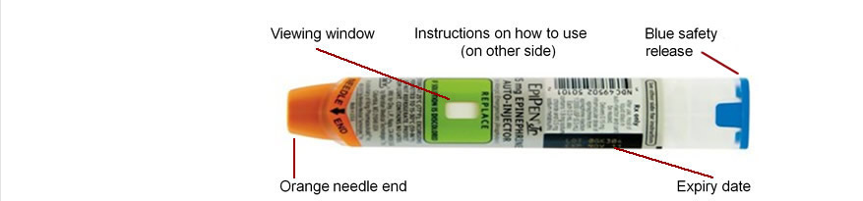

Locations of Epi Pens & Defibrillators

Room/Area | Epi-Pen | Defibrillator | Internal phone numbers
General office |  |  | 170, 139, 131, 120, 130
Sick Bay | Students’ own pens & School pens
Library | School Pen |  | 135
D10 (Food Tech Room) | School Pen |  | 127
Year 11 Centre | School Pen |  | 161 or 162
Year 12 Centre | School Pen |  | 167
ECA (Gym) | School Pen |  | 136

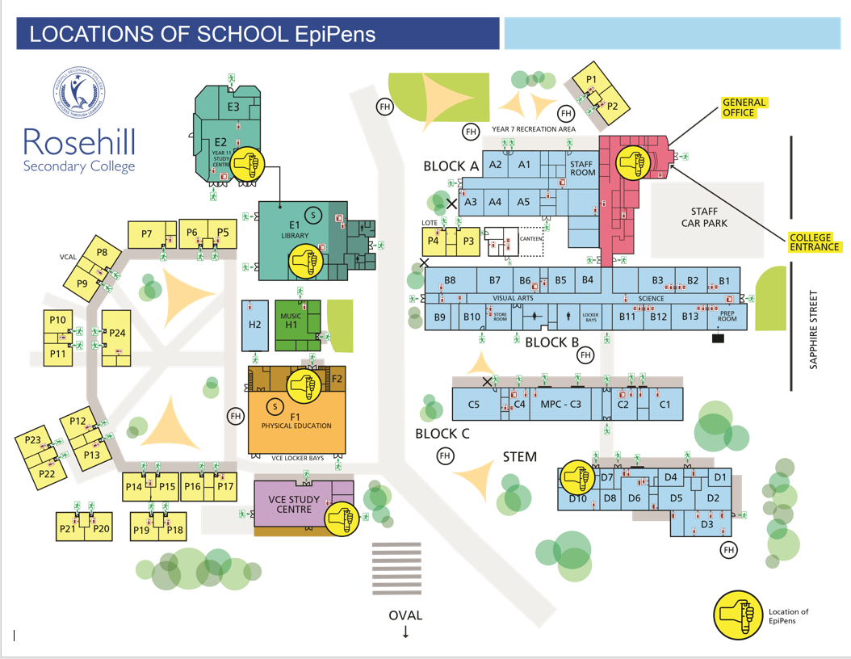
Communication Plan

Information about Anaphylaxis and the Rosehill Secondary College Anaphylaxis Management Policy will be communicated to members of the College community in the following manner:

